*Department of Information Systems*

***Systems Design & Development***

**

**Systems Specification for** *[Project Name]*

***Team Members***

|  |  |
| --- | --- |
| ***Student Number:*** | ***Student Name:*** |
| ***Student Number:*** | ***Student Name :*** |

**Plagiarism Declaration**

1. We know that plagiarism is wrong. Plagiarism is to use another's work and pretend that it is one's own.
2. This Systems Specification is our own work.
3. We have not allowed, and will not allow, anyone to copy our work with the intention of passing it off as their own work.

Full Name: ______________________________ Signed:_______________ Date: ____/____/2020

Full Name: ______________________________ Signed:_______________ Date: ____/____/2020

**Table Of Contents**

1. Introduction 1

1.1. Overview of Specification 1

1.2. Context & Scope of System Specification 1

1.3. Design Assumptions & Constraints 1

2. User Interface & Dialogue Design 1

2.1. Wireframe Diagram or Windows Navigation Document 2

2.2. Screen Standards 2

2.3. Detailed Screen Layout 2

3. Design Sequence Diagrams 2

3.1. Design Sequence Diagram 1 2

3.2. Design Sequence Diagram 2 3

4. Design Class Diagrams 3

5. Entity Relationship Diagram 3

6. Report Design 4

6.1. Report 1 4

6.1.1. Detailed Output Requirements 5

6.1.2. Report Layout 5

7. Input-Output Standards & Controls 5

7.1. Formalised Outputs: 6

7.2. Standards for User Interfaces 6

7.3. Standards for Dialogues 6

7.4. Standards for Controls 6

7.5. Built-In Validation to Ensure Requirements are Met 6

7.6. Input Integrity Controls 6

7.7. Output Integrity Controls 6

8. Implementation Plan 6

9. Test Plan 7

9.1. Test Environment 7

9.2. Test Items 7

9.3. Test Approaches 7

9.4. Problem Tracking (Test Cases) 8

9.5. Test Schedule 8

***Important Notice***

**The comments and suggestions provided in this template must NOT be present in your final submission! Try to customise, apply and re-work this template as much as possible to ensure that your Project’s Value Proposition is maximized** (i.e. Try to avoid just completing this document, heading by heading, and then just updating the contents page). **If nothing else, please just ensure to remove the initial content guidelines provided in this template in each section** (that includes this paragraph!). **The template is only here to assist you in completing your Systems Specification Document, you must try and find ways of showing us that you have actually thought about what each section means, how it creates value, and how it applies to your specific understanding of the problem, and your solution.**

***General Hints/Tips***

1. **The contents page makes use of Microsoft Word’s built in “Table of Contents” feature (found on the far left under the References tab). Try and make use of these helpful built in features** (e.g. once you have completed your document, get Word to automatically ensure that the contents page is accurate and has the correct page numbers by first right-clicking on the table of contents and selecting “Update field” which then updates any altered headings and inserts the correct page numbers)
2. **You should be able to generate an Initial/Draft ERD directly from your SQLExpress database. Doing this is a great way to reduce the amount of work you have to do, while also ensuring completeness. Take the generated model and modify it / comment on it / restructure it for the purposes of your project.**

# Introduction

## Overview of Specification

The following document will provide details about the poppel ordering system, details of how it has been built and how it works.

The project follows the user requirements specification phase we developed earlier, This phase of the project focuses at the design phase were we complete the System Development Life Cycle

This document provides details about how the design, implementation and testing phases of the system was conducted.

The project **is finished\***. The poppel ordering system is ready to be deployed and used.

## Context & Scope of System Specification

Poppel is a manufacture and importer of confectionary and soft drinks and is based around the Western Cape. Because Poppel has many customers, the management approached us to create a system that enables customers to buy using a **phone call.**

The overall project objective was to create a system that meets all our clients needs, Meaning the system built has to be functional, reliable, maintainable, secure and improve all daily operations, The required inputs and outputs of the system guided us in the design of the system in such a way that we designed the system to be user friendly.

## Design Assumptions & Constraints

*This section describes any constraints in the system design (reference any trade-off analyses conducted such, as resource use versus productivity, or conflicts with other systems) and includes any assumptions made by the project team in developing the system design.*

# User Interface & Dialogue Design

*In this section we will show the flow diagrams of where each button press will lead the user and provide screenshots of all forms explaining what formstate the form is in and what actions can the user take on that form and the output that will result, we’ll also explain about the various controls/components that are on the form and justify them.*

## Wireframe Diagram or Windows Navigation Document

* ***Flow diagram***

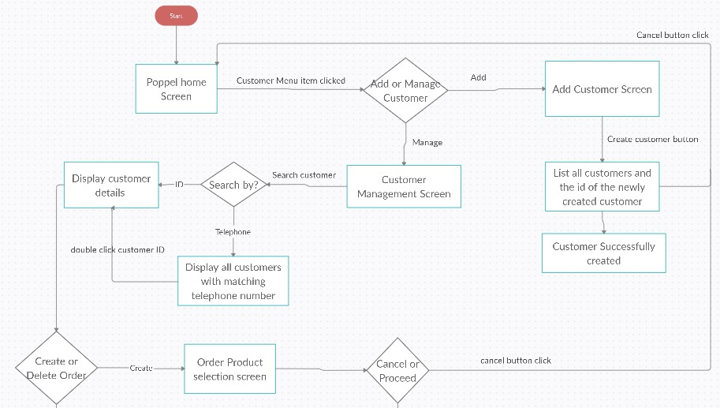

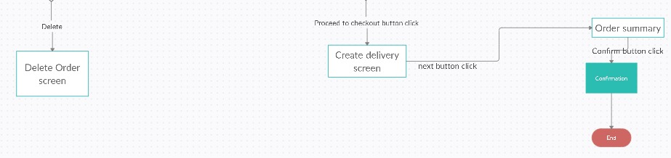

## Screen Standards

* *Layout:*
  + *The controls have been positioned from left to right*
  + *Screens was made to ensure it works on all screen sizes*
* *Color*
  + *Background color: gray*
  + *List view: white with black border*
* *Font:*
  + *Microsoft Sans Serif*
  + *Different sizes have been used to aid in making system user friendly.*
* *Overall appearance:*
  + *The system has a simple design, that promotes user friendliness.*

## Detailed Screen Layout

* ***The Customer management form***

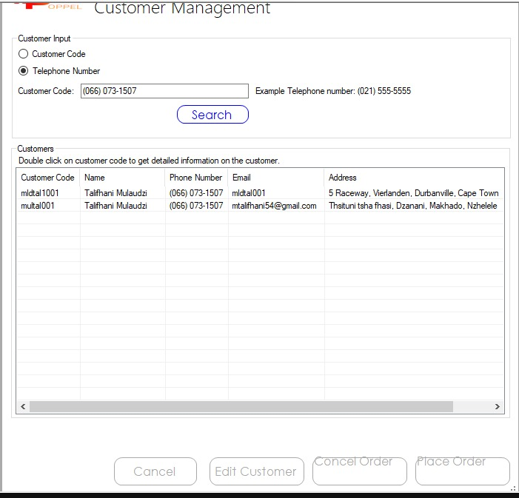

* ***The Order summary form***

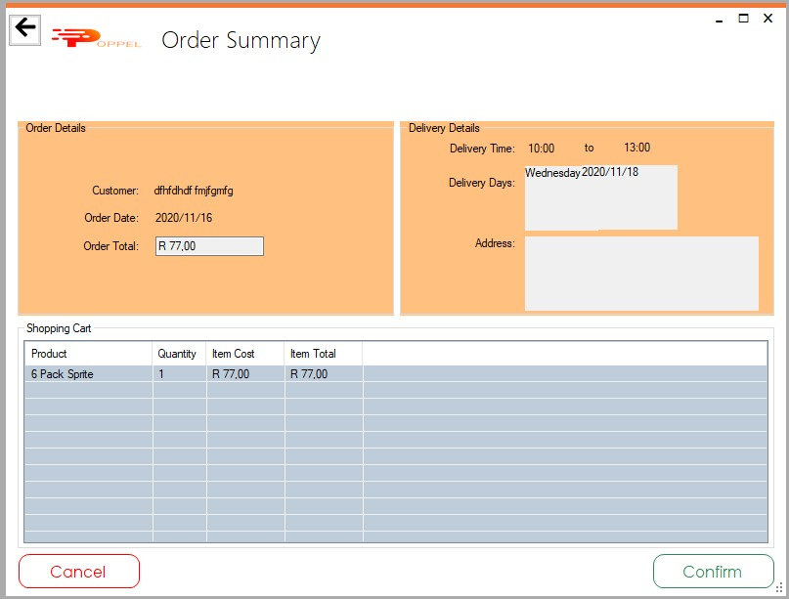

* ***The Expiring product form***

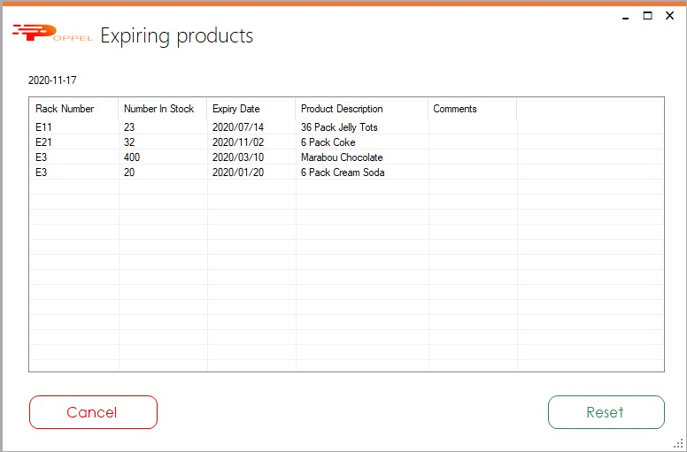

* ***The Customer managemenr(Edit) form***

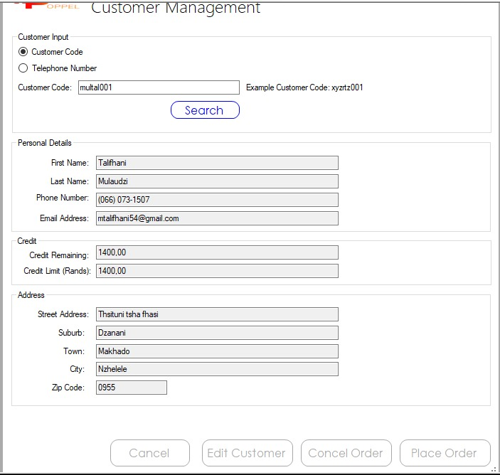

* ***The order created form***

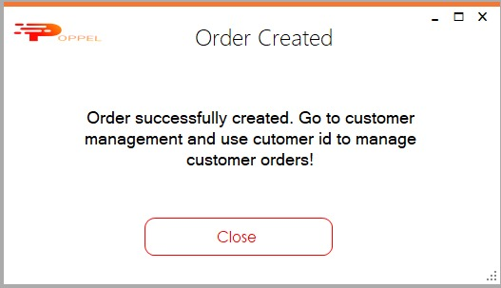

* ***The create customer form***

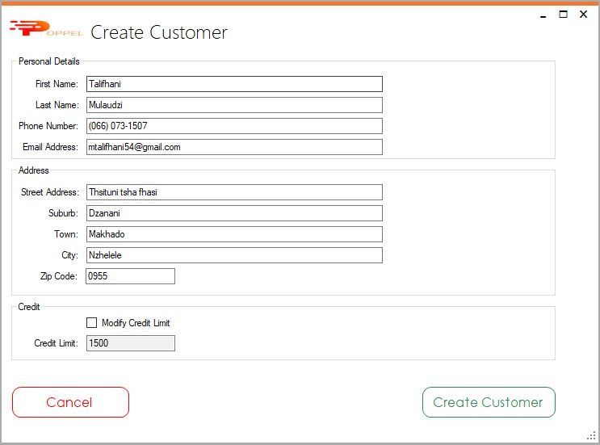

# Design Sequence Diagrams

## Design Sequence Diagram for placing order

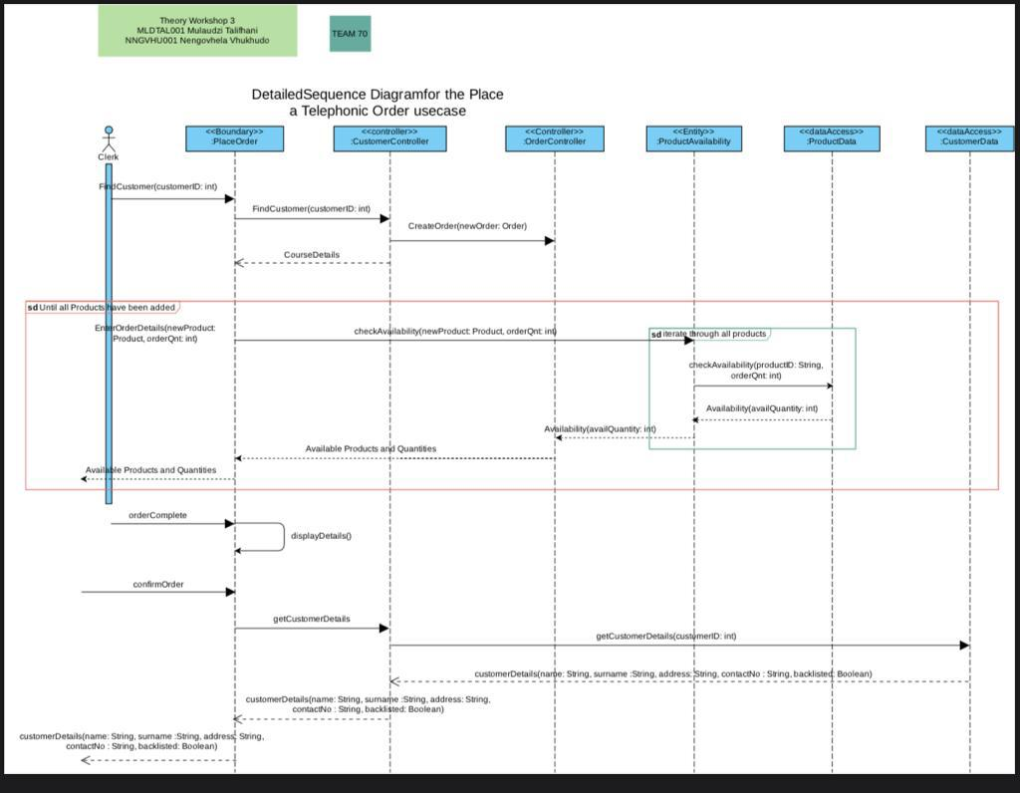

# **Design Class Diagrams**

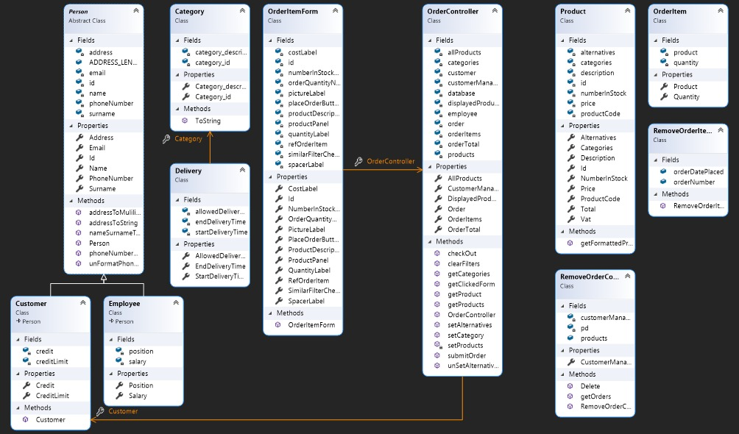

# **Entity Relationship Diagram**

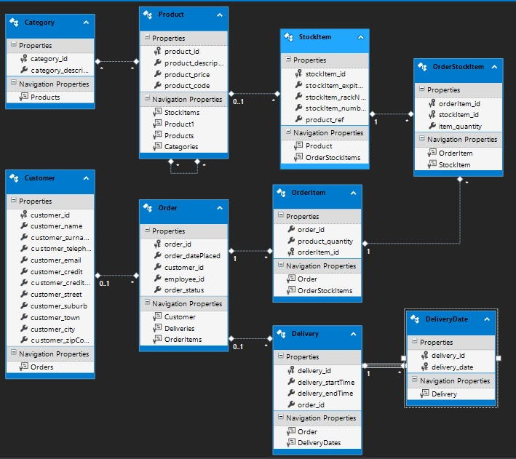

# **Report Design**

## Report 1: Occupancy Level Report

This report shows all the expired items from the start date specified to the end date specified, together with the items that are left available. This data will be shown inside a listview. This report provides information that can be used by management to learn from the past and plan for what to buy most and least in the future

### Detailed Output Requirements

1.Output type & ID: Summary report for management

ID: R001

2. Report Objectives: To provide information about occupancy levels to enable the management decide on how to distribute the next stock they buy

3. Audience: management.

4: Content: a summary of how the items are selling

5. Layout: Listview

6. Selection: select the dates and press generate report button, The report will then appear on the listview

7. Sequence: ordered from early expiry to late expiry

8. Comparison:

9. Grouping: Grouped by date

10. Media to be used: Electronic, can be printed

11. Frequency, Timing, delivery: receptionist can view anytime, Emailed to management as per request and at the end of every month.

12. Distribution: management

13. Privacy, Security & integrity requirements: The user must have signed in.

### Report Layout



# **Input-Output Standards & Controls**

***The system built for the hotel has been developed in a manner that will prioritize functionality and security. This is evident from the manner in which customer accounts are created and maintained.***

## Formalised Outputs:

*All key system outputs should be displayed on the screen. You should be able to display the confirmation letter on the screen if requested, but no other forms of output (printed report, email and fax) are required. What were the formalized forms of output included in your system?*

## Built-In Validation to Ensure Requirements are Met

*What were the validation controls built into the system to optimize the performance of the application and to minimize the possibility of user error which may hinder system performance?*

## Input Integrity Controls

*Describe any input integrity control included in the system*

## Output Integrity Controls

*Describe any output integrity control included in the system*

# **Implementation Plan**

For the implementation process we were working as a pair using agile methodology, where different functionalities will be created separately then integrated at the end of the implementation phase.

It took us four weeks to finish the implementation phase and testing it

**Week 1:**

We implemented the Customer functionalities and forms. Adding, editing and deleting a Customer and simultaneously test.

**Week 2 - 3:**

Implemented the ordering functionalities and forms. Adding, editing and deleting customer and simultaneously test , to ensure correct functionality.

**Week 4:**

Tested the system and called other people to test if the system was functional, user friendly and secure.

# **Test Plan**

*In this stage of development we tried hard break the system in order to ensure that we submitted to Poppel a system that is functional, errors and bug frees, as secure as possible and most importantly meets all of the Poppel’s requirements*

## Test Environment

*Describe the minimum hardware & software requirements*

*we have built a System that has very low minimum requirements to ensure that the system can be used at Poppel.*

*Minimum hardware requirements:*

* *Intel core i3 inside*
* *2 cores*

## Test Items

*Provide a description of all the features to be tested*

*Ordering features tested:*

* *Add a Order*
* *Edit a Order (Both edit and delete)*
* *List Order item*

*Customer features tested:*

* *Add a Customer*
* *Edit a Customer (Both edit and delete)*
* *List All Customers*

*Report features tested:*

* *Occupancy levels*

## Test Approaches

*Describe the types of tests which will be performed*

The most used test approach of which we have used is alpha testing and beta testing.

We also used the following test approaches:

* **Unit testing, integration testing and acceptance testing -** during Customer functionality and Ordering functionality testing.
* **Alpha testing, beta testing and System testing** – after all the unit testing and when thought the entire system was ready to be deployed.

## Problem Tracking (Test Cases)

*Describe the process followed for tracking and resolving errors*

* Case 1 : duplicates
  1. Inserting a pre-existing customer.
     1. The system response was made in way to assign the different cunstomerID
* Case 2 : leaving out required information
  1. While creating and editing a guest account:
     1. The create a guest button is disabled which is what we expected and displays an error
  2. While creating and edit a Order:
     1. The system responds that some information is missing, which is what we expected.

## Test Schedule

*Describe how the test schedule was co-ordinated with the development schedule*

Since the agile methodology was used testing for functionality and errors was done at the end of each phase. Any problems we encountered were noted and fixed before starting the implementation of the next phase.

Week 1:

* Tested Customer functionalities

Week 2 & 3:

* Tested Order functionalities

Week 4:

* Opened it to the public for further testing